TP3: UGRacing Pit Side Software

Background
UGRacing are a student-run team who annually enter a single-seater racing car into the national Formula Student competition. There are various electrical sensor systems on the car which all communicate with each other using a technology called CAN (Controller Area Network). CAN is a robust communications protocol, specifically designed for this purpose. Messages on the CAN Network consist of an 11-bit identifier followed by an 8-byte data packet. Rather than specify a “sender” and “receiver” for the data, the CAN identifier specifies what type of data the packet contains. For example a packet with the identifier 1E0₁₆ would contain road speed sensor data in the UGRacing car.

Aim of the Project
UGRacing would like a software suite to be developed which can be used to observe the car’s sensor values when it is in the pit. A PC connection to CAN is available using CAN-USB adaptors. For the purposes of this project, the only knowledge required about the operation of CAN is the packet format and that the data rate in the car is 125kbps – the USB adaptor handles the more complex properties.
A freescale microcontroller board will be provided which produces a simulated CAN output that is similar to what could be expected of typical in-car sensors.

Requirements
The project has the following requirements:
- Write the software suite in C#, using Microsoft Visual Studio 2008. This provides an easy to use drag-and-drop editor for the user interface elements of the project.
- Provide options for selecting the CAN data rate for the CAN-USB connection.
- Write functions to convert the standard UGRacing CAN formats into displayable values.
- Define an API to allow user interface modules to be created to display CAN data. A simple example of the type of module required is illustrated in Figure 1, with the left hand module containing a single live data value and a historical graph and the right hand module containing only data values. The interface to each module should take the following form:
void ProcessCAN(UInt16 can_id, UInt32 can_packet);
The main program can then pass any received CAN data to the modules using this function and it is up to the module to decide whether or not it needs to update itself based on the data and CAN identifier.
- Implement as many modules as possible to show existing sensor values on screen.
- Test the software with the microcontroller board, adding to the existing microcontroller code if desired.
- Demonstrate the working end-product to UGRacing representatives.

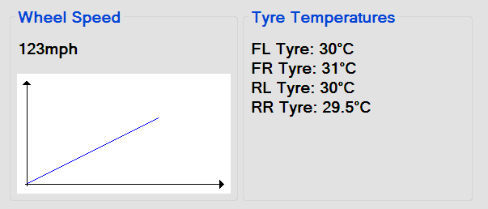
Figure 1: Simple example of what display modules may look like.

Contact Details
For any clarifications on the requirements of the software please contact Liam MacIsaac (l.macisaac@elec.gla.ac.uk).

See www.formulastudent.com
See www.canusb.com
Available at www.dreamspark.com free of charge.
Explanations of these CAN formats will be provided.
A table of sensor CAN IDs and the packet data formats is provided.

